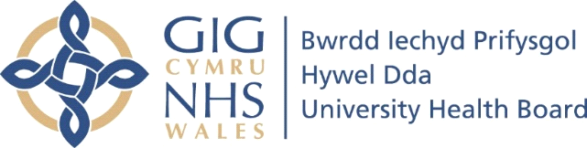

FURTHER INFORMATION

If you have any remaining questions or concerns following the Health Board’s response:

Please let us know as soon as you can as there are additional steps we can take to try and assist you in resolving your concerns:-
- You can request that the Health Board review the response provided and address any outstanding concerns you may have via letter or email (whichever is your preferred method of correspondence).
- You may find it helpful to meet with a senior member of staff to talk through the Health Board’s response, to discuss any outstanding concerns and to receive additional clarity on any explanations you are unsure about.

Llais (formerly Community Health Council)
We can help with complaints advocacy
If you need to raise a concern about an NHS or social care service, you can talk to us. Our trained, dedicated complaints advocacy staff will provide you with the free, independent, and confidential support you are entitled to.
They will help you raise your concern and:
- Support you to make a complaint about a service, care or treatment provided or paid for by the NHS or local authority
- Support you to make a complaint on someone else’s behalf, including if someone has died
- Listen to your concerns
- Put you in touch with other organisations if we think that someone else can also help
- Answer questions about the process and explain your options
- Provide a step-by-step guide to the process and offer some tips
Get in touch with your local Llais team and one of our team will talk to you about your concern, what sort of help you think you require and if you have any particular needs such as large print materials or access to someone who can sign.
If we can help you, we’ll tell you how. If we can’t, we’ll do our best to advise who can.

Llais West Wales Offices - Telephone - 01646 697610
E mail: westwalesadvocacy@llaiscymru.org
Carmarthen
Llais Carmarthen
Suite 5, 1st Floor, Ty Myrddin, Old Station road
Carmarthen
SA31 1LP
Milford Haven
Llais Milford Haven
Suite 18 Cedar Court, Havens Head Business park
Milford Haven
SA73 3LS
Aberystwyth
Llais Aberystwyth
WG building, Rhodfa Padarn, Llanbadarn Fawr
Aberstwyth
SY23 3UR
Please note that we are unable to provide advocacy services for children and young people who need to raise a concern about social services.

Public Services Ombudsman for Wales:

You can also contact the Public Services Ombudsman for Wales who may also review the matter:

The Ombudsman can accept complaints through her website, by e-mail, in writing, or over the phone. The Ombudsman’s contact details are:

Phone: 0300 790 0203
Email: ask@ombudsman.wales
Website: www.ombudsman.wales
Address: Public Services Ombudsman for Wales
1 Ffordd yr Hen Gae, Pencoed, CF35 5LJ.

Please be aware that if you wish to approach the Ombudsman with a complaint, you should do so promptly. The Ombudsman is able to consider complaints made to her within one year of the matters complained about (or within one year of the
complainant becoming aware of them). If your complaint is about something that happened more than a year ago, but you complained to the Health Board (or Trust)
within one year, you should complain to the Ombudsman, if you wish to, within twelve weeks of this response.

The Ombudsman will determine on a case by case basis whether to consider a complaint, but she will not generally consider a complaint about something that happened more than a year ago, unless the complaint to the Health Board or Trust was made within a year and the complaint is referred to the Ombudsman within twelve weeks of this response.

